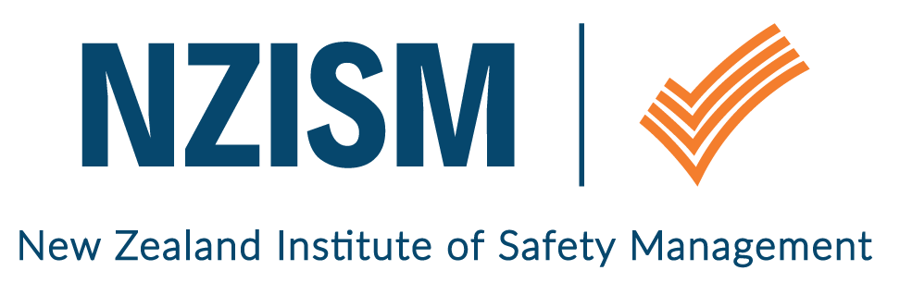
Wellington Branch

November 2018 Newsletter

Review of last event | Sara Alridge of Chemsafety, was our November guest presenter. She provided an overview of the Health and Safety at Work (Hazardous Substances) Regulations to help members navigate requirements to ensure risks are understood and managed correctly.  We were delighted with the number of members who attended (34) and also welcomed guests who were attending a NZISM seminar for the first time.  If you would like a copy of Sara’s presentation, please contact her directly on sara@chemsafety.co.nz.  Chemsafety have also generously offered a free walkthrough site visit to Wellington NZISM members. The visit would involve Chemsafety meeting members on their work site and looking how substances are used and discuss any compliance issues Chemsafety may identify. Sara can also offer this type of walkthrough for asbestos management and occupational hygiene. If you are interested please email sara@chemsafety.co.nz to set up a date and time.
November event  The National Library  70 Molesworth Street  Wellington | Tuesday 4 December  12:00pm – 12:15pm: Arrival and networking  12:15pm – 12:30pm: Meet your committee and overview for 2019  12.30pm – 1.15pm: Networking and Christmas treats (accompanied with tea/coffee/water)  Please rsvp via Eventbrite for this event.
Bring a guest
Members are encouraged to bring along guests to the monthly seminars. Whilst there is a preference to translate the visits to membership, our focus is on growing risk management awareness amongst a cross section of people. Safety is everyone’s responsibility – not just the H&S professional.
Local H&S scene / What’s going on | Have you or your organisation done an activity recently that you’d like to share with other members? We welcome your input which can be supported by photos of the event if you wish. Please email us at well.nzism@gmail.com.  Members may find this information about serving alcohol safely helpful, especially as the silly season approaches.  As well as Movember (good luck to anyone who is either growing a moustache and fundraising or enduring their partner’s commitment to the cause!), 25 November is White Ribbon Day.  If you’d like to promote an event or share information that would be of interest to NZISM members, please email well.nzism@gmail.com.
Other Information | Contact information  A reminder to ensure your profile on the NZISM website – https://www.nzism.org is up to date. The success of the Wellington branch relies on the input of its members and our ability to send communications to you.  Because emails have become increasingly unreliable as a means of reaching members, we will start to move towards using the Branch site on the NZISM website as the main communication forum. Please let other members know if they mention they are not receiving emails from us.  Thank you and welcome  We welcome Jan Houston to the leadership group. Jan will provide general support to the group to help ensure we keep in touch with our members.
Important stuff to know | Wellington monthly events are scheduled for the first Tuesday of every month at The National Library, Thorndon. Keep an eye on the NZISM Calendar on the website for more information.  A reminder also, to check out our neighbouring Regions events on the NZISM Calendar. There may be something on in another Branch that is relevant to you.

